Bill Drafting Template User Guide

Word 2013/2016

Montana Legislative Services Division

Revised August 2022
for
2023 Legislative Session

Introduction

The Bill Drafting template for Word 2013/2016 is a tool to aid in drafting bills for the Montana Legislature. The template provides boilerplate language and standard section format to eliminate some of the clerical problems associated with bill drafting, but a template is not a substitute for the substantive knowledge needed to correctly draft bills. An understanding of the Bill Drafting Manual, published by the Legislative Services Division, is a requirement for bill drafting.

Contact:
ITSD Service Desk
servicedesk@mt.gov
406.444.2000

General Operation

Template: A Word template is a collection of stored words, beginning formats, tool bar customization, and macros that when invoked at the start of a document controls the preparation of that document.

The template gets the MCA sections from the Legislative Services’ website, so an Internet connection is necessary to use it.

The template must be installed -- see Installation instructions at the end of this document.

The bill drafting template opens up with standard language and typeface, has headers and footers for a draft bill, puts the Strikethrough icon on the toolbar, and adds a Menu icon to the tool bar. The template has a series of macros that are available only for documents opened with the template.

Macro Language: Use the macros whenever they can be used. Take the time to learn them now, and they will save immense amounts of time later. Time saving is only a part of the reason for the macros. They ensure accuracy, and they are also an important part of the Legislative Services Division’s bill drafting system. The macros provide certain coding to a bill draft that is used in producing the bill for introduction.

Don't change the material inserted by a macro and don’t edit a bill in the interests of esthetics or personal preferences -- required page ends, multiple tabs, and other codes inserted to make the draft look good must be removed by our office. Nice formatting in drafting wastes time because the introduced bill will appear differently. The "{}" codes in drafts are used to surround material that is deleted before a bill is printed for introduction. If you delete the ending "}", all the material following until the next ending "}" is deleted -- that's usually a section.

Begin Drafting: Start drafting a bill by clicking the Menu icon you installed. To manually start the macro use the Menu icon you added to the Quick Access Tool bar in the Installation instructions at the end of this document. Installation instructions
If you did not install a shortcut click the Developer tab, then Macros and manually run the menu macro referenced in the Installation Instructions linked above .
(Note that an appropriate Amend MCA code must be entered before the MCA in Title (last) option can be used).

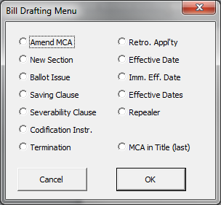

For Support Contact:
ITSD Service Desk
servicedesk@mt.gov
406.444.2000

Macro General Operations: To insert any standard bill drafting section, place the cursor where the section goes, click the Menu icon (with the scales of justice), and then choose the appropriate menu item. For straight boilerplate (severability clause, immediate effective date, etc.), the macro will insert the section into the bill without further input. For some sections, you must provide information. The codification instruction macro pops up a form asking which sections are to be codified and in what Title, chapter, and part. Other macros complete the basic section, but you must go into the section and provide missing language. The effective date sections do not insert dates; you must go into the section and provide the dates. Some macros amend the title while inserting a section. The repealer and date sections (immediate effective date, termination, etc.) amend the title as the macro runs. The title changes are made at the end of the title, so insert these sections in the order that you want them to appear in the title. Last but not least, the title macro sweeps through the bill and adds a clause to the title indicating which MCA sections have been amended in the bill. Generally, the title is written last so you can accurately reflect the subject of the bill, and the title macro is the last of the title to be finished.

Individual Macros
Menu: The basic menu, chosen from the Menu icon on the toolbar. Have the cursor in place before using the macro because the chosen section appears at the cursor insertion point. If you don’t want it where it appears, use Undo (blue left curving arrow) and try again.

Amend MCA: The "all-in-one" macro. Use to retrieve an MCA section. Have the cursor at the left margin where you want the section. It retrieves the section, with the necessary amendatory wording at the beginning, automatic paragraph number, section number tagged for the title macro, opening and closing quotes, and an internal reference report. The macro waits to accept a series of MCA sections if you wish. After the first section, it gives the last section number retrieved, which helps when entering a long series of sections. Check each section in the internal reference report and use Word to put an "x" by each cite checked. Don't mark a printout of the bill with a pen or pencil because the mark is lost at the bill’s next printing and doesn’t travel with the electronic version.

Note: If you receive an error #4605 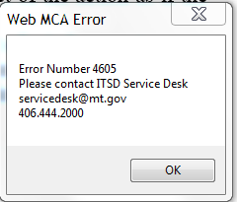 this is caused by a setting in Microsoft Word. Please contact your Help personnel if needed to change this setting.
In Microsoft Word, a blank document, click File and Options. Verify the checkbox Open e-mail attachments and other uneditable files in reading view. Having this checked breaks the macro.

New Section: At the cursor, inserts
NEW SECTION. Section 1. _
The cursor is within bold codes for writing the catch line. Click off bold when starting the section text. The section number is automatic and adjusts if sections are inserted before it.

Ballot Issue: At the cursor, inserts a standard section for putting a statewide issue on the general election ballot in November 2010. You must complete the For and Against Ballot Language.

Saving Clause:
Severability Clause: At the cursor, inserts either a standard saving clause or severability clause. No drafter intervention is required. There isn’t an Anonseverability clause@ macro.

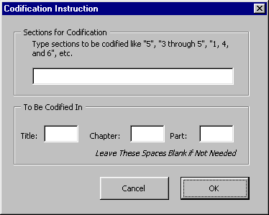
Codification Instr: Creates a codification instruction at the point you put the cursor. Enter the section numbers from the bill that are appropriate. Use a phrase like the examples, but don’t set them in quotes. The Title number is required -- enter chapter and part numbers if appropriate.

Termination: Inserts a termination section at the cursor and inserts the necessary phrase in the title. It stops for you to fill in the termination date. Avoid use of Termination, Contingent Effective Date, and Contingency clauses because of the complexity of maintaining multiple versions of these types of sections.

Retro. Appl'ty: Inserts the following and inserts the necessary phrase in the title:
NEW SECTION. Section 1. {standard} Retroactive applicability. [This act] applies retroactively, within the meaning of 1-2-109, to _

Effective Date:
Effective Dates: At the cursor, inserts effective date or dates section and allows you to fill in the applicable date or dates. It inserts the necessary phrase in the title to show an effective date is within the bill.

Imm. Eff. Date: At the cursor, inserts an immediate effective date section in the bill and inserts the necessary phrase in the title.

Repealer: Inserts a standard repealer clause at the cursor. Automatically lists internal references. Keep entering one section at a time in numerical order. The form shows the last section you repealed. Takes the listing and puts it into the title. Check each section in the internal reference report and use Word to put an "x" by each cite checked. Don't mark a printout of the bill with a pen or pencil because the mark is lost at the bill’s next printing and doesn’t travel with the electronic version.

MCA in Title (last): LAST drafting macro. Lists sections amended in the bill into the title in the order in which they appear in the bill. The sections must be in numerical order in the bill. Put the cursor where you want the listing to appear (the first character of the sections list is a semicolon). If you want to run the macro a second time, just delete the MCA listing in the title created by the first macro and run it again. If there is only one MCA section in the bill, you will have to correct the title language a bit.

Installation (Windows 7 or 10 & Word 2013/2016)

- Step 1: Copy Net Bill Drafting 13.dotm to your computer.
  - In your Microsoft Edge internet browser, copy the template Net-Bill-Drafting-13-16.dotm from the current Bill Drafting Page (https://leg.mt.gov/information-legislators/agency-bill-drafting/). 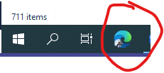
  - To do this, open Microsoft Edge (there are issues with Google Chrome downloading this file), right-click on the “Template” hypertext link that is located near the bottom of the page under the title "For Help Using These Templates". 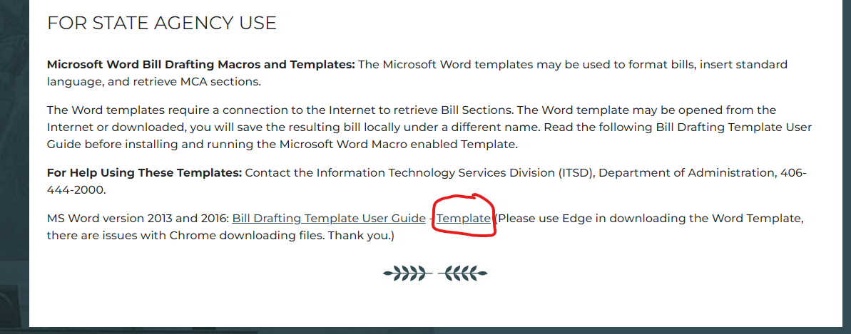
  - In the drop-down menu, choose "Save link as"… and save it to to your local document location, my documents or a shared network drive where you keep your Word documents.
  - If you experience a warning message in the upper right stating "net-billdrafting-13-16.dotm can't be downloaded securely", hover over the right side of the error message and three dots will appear – left-click on the three dots and left-click "Keep":
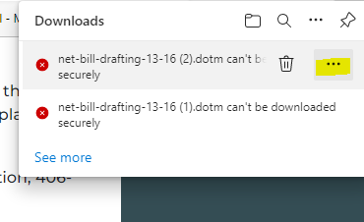
  - If another pop-up opens that says "This file can't be downloaded securly", left-click on "Keep anyway":
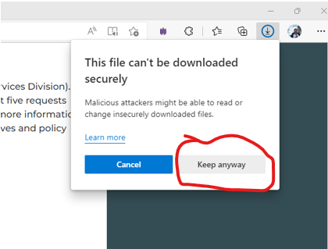
- Step 2: Open template:
  - In Microsoft Word, open Net Bill-Drafting-13-16.dotm from the Saved location
  - Note: Based on your computer security settings you may need to enable the template by left-clicking "Enable Cotent" in the "SECURITY WARNING" (see example, below), it is a .dotm so if you save it becomes a docx. To not see this message the .dotm needs to be in a trusted location like My Documents or Desktop or other trusted location
  - EXAMPLES: 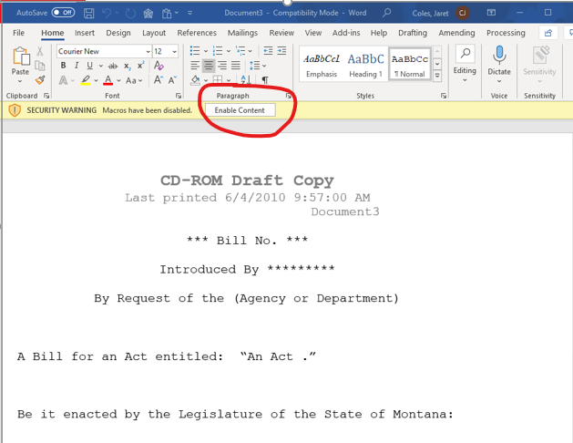 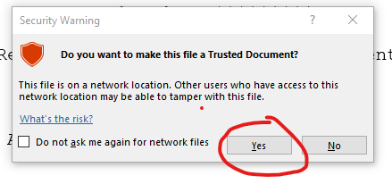
- Step 3: Add Menu button to QAT – Quick Access Toolbar:
      - Right click on your Quick Access Tool bar and select Customize Quick Access Toolbar
        - You can run the Menu macro manually if you do not wish to customize your tool bar
      - Select Macros from the Choose Commands from drop down list
      - Select the embedded macro TemplateProject.NewMacros.menu from the list
        - This is the main menu for the Template macros
      - Click the Add button to add the menu macro to the QAT
      - Click Modify before OK, it is below the Customize box
      - Change the Icon picture to something you like, we like the Scales of Justice
Change the name of the icon to something you like, we like Word Bill Drafting

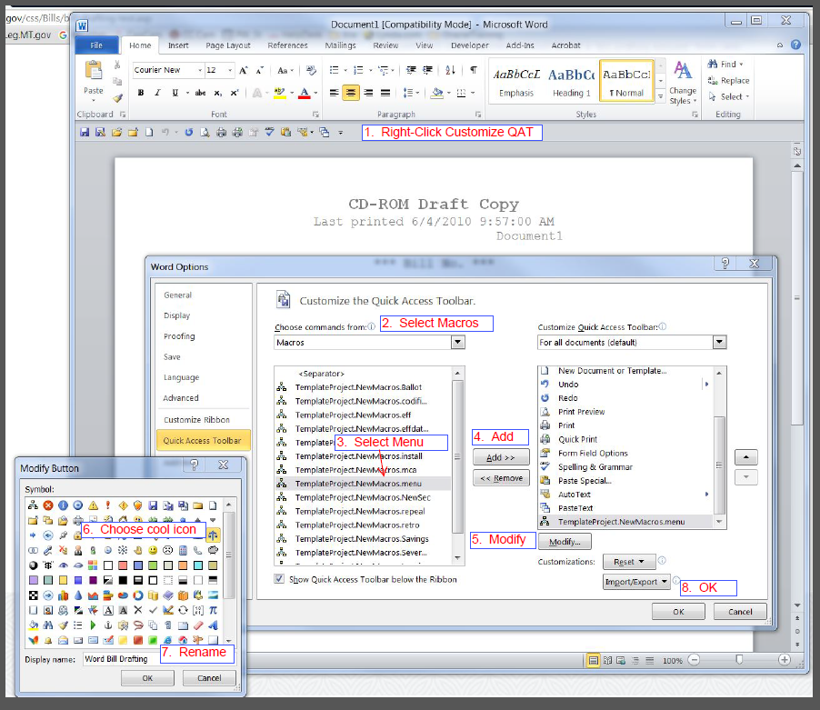
  - Results in:
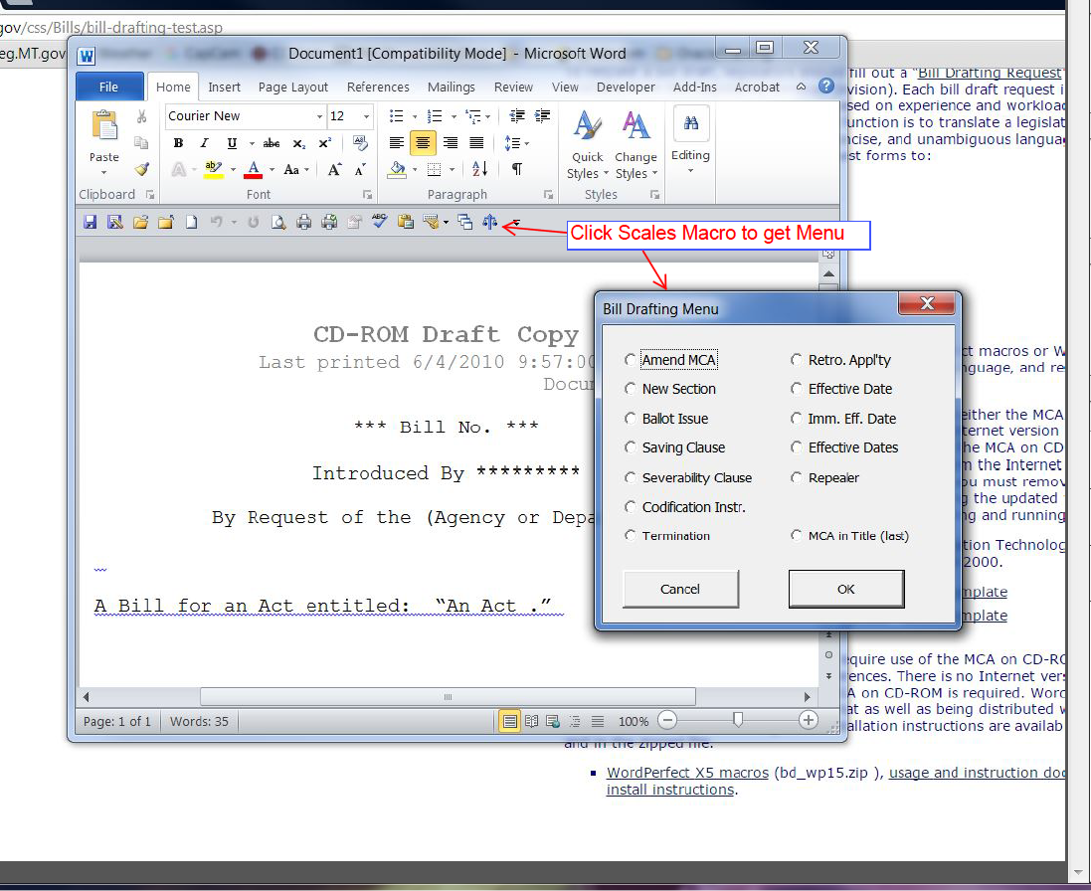

Post Installation

The bill drafting template must be loaded each time Microsoft Word is started prior to being able to work on a bill.

If you see the following error (after making the Quick Access Toolbar shortcut) the template is not loaded in Word.

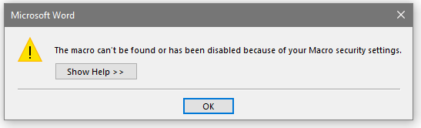

Contact:
ITSD Service Desk
servicedesk@mt.gov
406.444.200

