**** bill NO. ****
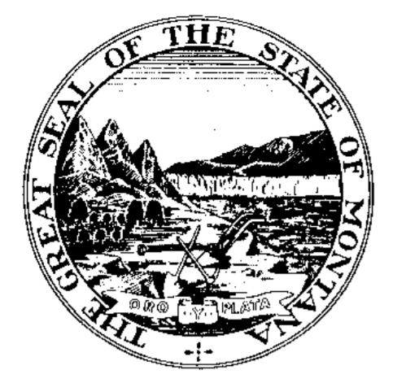INTRODUCED BY ****
By Request of the ****

A BILL FOR AN ACT ENTITLED: “AN ACT CLARIFYING AN AGENCY'S DUTY TO PERMIT INSPECTION, EXAMINation, AND REPRODUCtion of RECORDS FOR LEGISLATIVE AUDIT PURPOSES; providing that audit materials are confidential prior to PRESENTATION OF the audit report to the legislative audit committee; PROVIDING THAT FAILURE TO COMPLY WITH DUTY CONSTITUTES OFFICIAL MISCONDUCT; AMENDING SECTION 5-13-309, MCA; and PROVIDING AN IMMEDIATE EFFECTIVE DATE.”

BE IT ENACTED BY THE LEGISLATURE OF THE STATE OF MONTANA:

Section 1. Section 5-13-309, MCA, is amended to read:
"5-13-309. Information from state agencies. (1) All state agencies have a duty to aid and assist the legislative auditor whenever the legislative auditor requires the inspection, examination, or audit of books, accounts, activities, and records.
(2) (a) Except as prohibited by the Internal Revenue Code, the legislative auditor, or the auditor's designee, may have access to, examine, and reproduce at any time the books, accounts, activities, and records, confidential, privileged, or otherwise, in whatever format, including electronic data, of a state agency. This section may not be construed as authorizing the publication of information prohibited by law.
(b) Prior to presentation of an audit report to the audit committee, all audit working papers, including communication, notes, memoranda, preliminary drafts of audit reports, and other data gathered in the preparation of audit reports by the division are confidential and are not open to public inspection.
(c) Failure or refusal by an elected or appointed official to provide or allow access, examination, or reproduction of books, accounts, activities, or records, or otherwise interfere with or obstruct these activities is considered official misconduct as specified in 45-7-401.
(3) The head of each state agency shall immediately notify both the attorney general and the legislative auditor in writing upon the discovery of any theft, actual or suspected, involving state money or property under that agency's control or for which the agency is responsible."

NEW SECTION. Section 2. {standard} Effective date. [This act] is effective on passage and approval.
- END -

