**** bill NO. ****
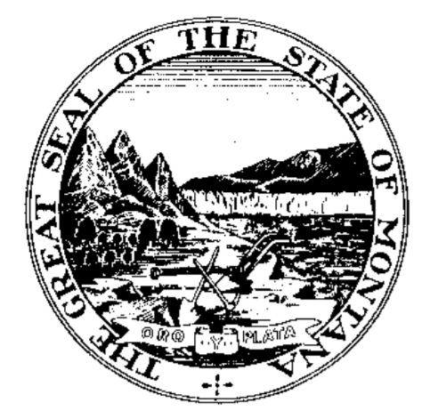INTRODUCED BY ****
By Request of the ****

A BILL FOR AN ACT ENTITLED: “AN ACT modifying timing of audits; PROViDING FOR AN ANNUAL AUDIT OF THE STATE ANNUAL FINANCIAL REPORT; PROVIDING FOR A TRANSITION FROM BIENNIAL TO ANNUAL AUDIT OF FEDERAL ASSISTANCE; providing guidance to LEGISLATIVE auditor on selection of agencies for auditing based on certain considerations; AMENDING SECTION 5-13-304, MCA; PROVIDING AN IMMEDIATE EFFECTIVE DATE.”

BE IT ENACTED BY THE LEGISLATURE OF THE STATE OF MONTANA:

Section 1. Section 5-13-304, MCA, is amended to read:
"5-13-304. Powers and duties. The legislative auditor shall:
(1) (a) perform an annual audit of the statewide annual financial report prepared by the department of administration in accordance with generally accepted accounting principles;
(b) continue to conduct a biennial single audit until June 30, 2025. For the fiscal year beginning July 1, 2025, and for each fiscal year thereafter, the legislative auditor shall perform an annual audit of federal financial assistance provided to the state that meets the requirements established by the federal government;
(c) conduct, or have conducted, compliance audits or audits of the financial affairs and transactions of state agencies at an interval determined by the legislative auditor taking into consideration the agency's operations, risk, and the complexity of its fiscal structure, and nature and extent of previous audit findings.
(2) conduct an audit to meet the standards and accomplish the objectives required in 5-13-308 whenever the legislative auditor determines it necessary and shall advise the members of the legislative audit committee;
(3) make a complete written report of each audit. A copy of each report must be furnished to the department of administration, the state agency that was audited, each member of the committee, and the legislative services division.
(4) report immediately in writing to the attorney general and the governor any apparent violation of penal statutes disclosed by the audit of a state agency and furnish the attorney general with all information available relative to the violation;
(5) report immediately in writing to the governor any instances of misfeasance, malfeasance, or nonfeasance by a state officer or employee disclosed by the audit of a state agency;
(6) report immediately to the commissioner of political practices any instances of apparent violations of the state code of ethics provided for in Title 2, chapter 2, part 1;
(7) report immediately to the surety upon the bond of an official or employee when an audit discloses a shortage in the accounts of the official or employee. Failure to notify the surety does not release the surety from any obligation under the bond.
(8) have the authority to audit records of organizations and individuals receiving grants from or on behalf of the state to determine that the grants are administered in accordance with the grant terms and conditions. Whenever a state agency enters into an agreement to grant resources under its control to others, the agency shall obtain the written consent of the grantee to the audit provided for in this subsection."

NEW SECTION. Section 2. Effective date. [This act] is effective on passages and approval.
- END -

