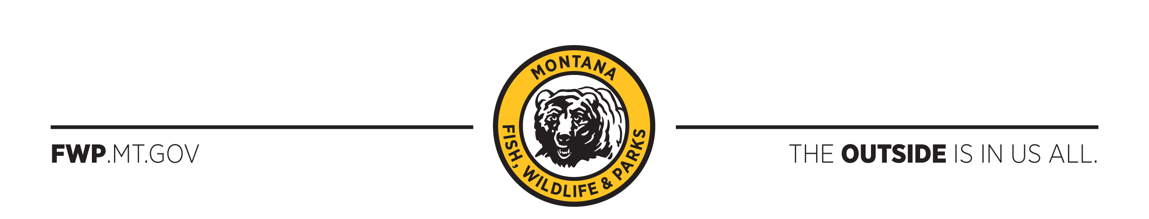

2020 White-Nose Surveillance : Positive and Pending Results
Yellow Counties represent those targeted for 2020 surveillance. Counties east of those targeted are assumed to already be positive for Pd and/or white-nose syndrome.

Represent counties with positive Pseudomyces destructans (Pd) detections. Pd is the fungus that causes white-nose syndrome in bats. No bats have been found to be suffering from the disease to date.
