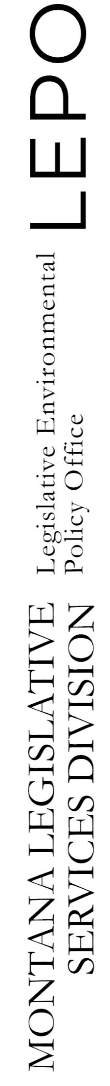
Jan. 5, 2022
Water Policy Interim Committee
Jason Mohr, committee staff

resources for wpic members

water rights handbook
Published by the committee since at least 2004, the Water Rights in Montana handbook summarizes the legal processes related to water rights. The handbook covers everything from adjudication of historical claims to enforcement of rights, and from permit applications to controlled groundwater areas. It also includes important contact information, a list of relevant water right forms, a glossary of terms, a listing of all government authorities related to water rights, and a summary of all water rights compacts with federal agencies and Indian tribes. This office printed 3,300 copies in 2018. The handbook will again be updated in 2022 or 2023.

reports
Aside from committee legislation, the most recognizable work product of an interim committee is a committee report. These reports include background information and expert testimony, which are used to bolster any committee findings, conclusions, recommendations or legislation.
- HJ14: Prospects for a future Water Court (2020)
- HJ40: Seeding clouds (2020)
- Climate and water rights (2020)
- A Right to Stream Conditions as They Existed: A Study of the Process for Changing a Water Right (Web-based summary) (2018)
- The Exemption at 45: A Study of Groundwater Wells Exempt from Permitting (2018)
- SJ2: Assuming Dredge and Fill Permits (2016)
- Issues of Water Availability and Supply (2016)
- Considerations for the Future of the Water Court (2016)

publications database
The Legislative Services Division maintains a searchable publications database, which may contain past legal opinions, evaluations of state agencies, special reports, and other documentation. The database is still under development, so results may vary.

website
The committee website, leg.mt.gov/water, includes agendas, meeting minutes, presentations, memos, and other relevant information. Also past committee work is available.

