

NEW
ECONOMIC DEVELOPMENT INITIATIVES

Presented to:

ECONOMIC AFFAIRS

INTERIM COMMITTEE
June 24, 2005

INTRODUCTION

Governor Schweitzer included economic development as one of his top priorities for the 2005 legislative session. As a result, a number of bills and appropriations were introduced and enacted that will enhance economic development in Montana.

This report addresses the initiatives that the Montana Department of Commerce is responsible for administering and delivering on behalf of the people of Montana.

This Report categorizes the initiatives into the following categories and discusses each in turn.
Grant and Loan Initiatives
Technical Assistance Initiatives
Tax Incentive Programs

ECONOMIC DEVELOPMENT GRANT AND LOAN INITIATIVES

HB 249 – Big Sky Economic Development Trust Fund (BSTF):

Overview:
This legislation will create the Big Sky Economic Development Trust Fund (BSTF) within the Coal Tax Trust Fund. The BSTF will be infused with $20 million of Coal Tax Trust Funds on July 1, 2005. Each year thereafter through 2025, 25 percent of the coal severance tax revenues to the permanent coal severance tax trust not required for other purposes will be deposited in the Big Sky Trust Fund.

Each year on a quarterly basis, the interest generated by the BSTF is deposited into a special revenue account. The funds in the special revenue account are statutorily appropriated to the Department of Commerce to administer pursuant to the statute that established the Trust.

Of the money in the state special revenue account, 75% must be allocated for distribution to local governments to be used for job creation efforts and 25% must be allocated to Certified Regional Development Corporations and local development organizations that are not part of a CRDC region.

Status:
The Department is in the process of writing the Administrative Rules and Guidelines to implement the program. It is anticipated that the Department will have several regional meetings this summer to get feedback from local officials, local economic developers, and others about the implementation of the program
This Fall, the Department anticipates entering into formal rulemaking and adopting rules before the end of October.

The Department anticipates taking applications from local governments and Certified Regional Development Corporations in January of 2006. We expect that interest earnings deposited into the special revenue account by that time will approximate $500,000.

HB270 – New Worker Training Program

Overview:
- HB 270 transfers the administration of the New Worker Training Program established during the 2003 Legislative Session from the Governor’s Office of Economic Opportunity to the Department of Commerce. The Legislative Auditor recommended this reorganization in an audit of the Governor’s Office of Economic Opportunity.
- HB 270 funds the program with $1,400,000 annually of general fund. The previous funding mechanism was thought to be improper since it used the INTERCAP program through the Board of Investments.
- The program has a Grant Review Board whose purpose is to adopt rules and guidelines and to review and approve applications for job training funds.
- The program can fund up to $5,000 in eligible training expenses for new workers. The match for the training is $3 State to $1 private.

Status:
- Both the Governor and the Legislature have appointed the members to the Grant Review Committee. Those members are;

Bob Henry
6 Redwood Lane
Butte, MT

Laurie Boutelle, Vice-President
First Interstate Bank
Miles City, MT

Joni Stewart, Executive Director
Glacier Action and Involvement Now
Cut Bank, MT

Linda Beck, Director of Business
Big Sky Economic Development
Billings, MT

John Cech, Dean
MSU-Billings College of Technology
Billings, MT

Andy Poole, Deputy Director
Montana Department of Commerce
Helena, MT

Ingrid Childress, Administrator
Montana Department of Labor and Industry
Helena MT

- The Department has drafted rules and guidelines that will be reviewed by the Grant Review Committee in the next few weeks.
- Following review and approval of the rules and guidelines, the Department will begin accepting applications from eligible applicants.

HB 271 – New Worker Training Appropriation FY2005

Overview:
- A legislative Audit of the Governor’s Office of Economic Opportunity identified a potential legal impediment to using the INTERCAP program to provide funding for the Worker Training Grants that had been approved by the Martz Administration. Five grants had been approved for a total of $2.17 million and assurances had been given to the companies that the money for training would be forthcoming.
- The legislature honored that commitment by appropriating the funding for the grants during FY2005.

Status:
- The Department has prepared and executed contracts with the following companies to employ and train new workers.
  - Printing for Less – Livingston (26 new jobs)
  - Montana Resources – Butte (195 new jobs)
  - Qwest – (27 new jobs)
  - Bresnan – Billings (96 new jobs)
  - Centene – Great Falls (80 new jobs)

HB2 – Indian Economic Development

Overview:
- The Schweitzer Administration prepared and delivered a letter to the appropriations subcommittee for Natural Resources and Commerce discussing the appropriation of $500,000 for Indian economic development. During those discussions, the Department informed the Subcommittee and each of the subsequent committees dealing with the budget that we would consult with the State/Tribal Economic Development Commission to get their recommendations about investing this money.

Status:
- The Department has requested a meeting with the State Tribal Economic Development Commission to discuss the investment of this funding. At this time a meeting is being arranged for mid-July.

HB 713 - Mission Assessment for Military and National Guard Installations

Overview:
- HB 713 appropriated $100,000 in general fund to the Department of Commerce to create a task force to conduct a mission assessment for the military and national guard installations in Montana and to promote the establishment of new installations and expanded missions.
- The task force will prepare and make a report to the Department. Based upon that report, the Department will prepare a report of recommendations to the Governor and the Legislature by September 1, 2006.

Status:
- The Department has contracted with Cascade County to fulfill the requirements of HB 713 as it relates to the Task Force and Report of Recommendations to the Department. Upon the receipt of that report, the Department will prepare recommendations for the Governor and the Legislature.

HB423 – Great Plains Dinosaur Park

Overview:
- HB 423 appropriated $500,000 from the state general fund to the Department to purchase the land and purchase or construct a facility for a park in Malta, to display the products of paleontological research in the area and to provide research facilities for paleontologists and complete necessary building upgrades. The Department may lease the property to a private, nonprofit entity for the purpose of operating the park.

Status:
- The Department is currently working with citizens and leaders from the Malta area and with the Department of Administration, Architecture and Engineering Division to evaluate the probable course necessary to accomplish the completion of the dinosaur park.
- The building would be owned by the State (Department of Commerce). Since no funding is provided for operation and maintenance, we are assuming that there would be no operational costs for the State of Montana. We assume that the Department would lease the building for a nominal amount to a locally-based private, non-profit entity or local government which would assume total responsibility for all operational costs of the 'Great Plain Dinosaur Park" which would include staffing, equipment, maintenance,
- According to Tom O'Connell, Administrator of the Architecture & Engineering Division in the Department of Administration, if the Department does have to purchase a site, either a vacant lot or a building, it would have to be professionally appraised and approved by the State Land Board.

ECONOMIC DEVELOPMENT TECHNICAL ASSISTANCE INITIATIVES

HB 481 – Main Street Program

Overview:
- The purpose of the Main Street Program is to assist communities in restoring and retaining the historic character of their downtown areas, to stimulate business investment, strengthen the local tax base, create employment opportunities, and, generally enhance the economic viability of downtown areas and historic districts.
- The Department was appropriated $125,000 in state special revenue funds each year (one-time-only) to implement this program.

Status:
- The Department is currently working with the National Trust for Historic Preservation. This organization created and operates the national program and HB 481 includes language directing the Department to work with the National Trust in implementing the program.
- We are in the process of setting up several training events around Montana so that local officials, economic developers and others can learn about the Main Street Program and decide if they want their community to participate.
- The Main Street Program is being organized internally with the Small Business Development Center Program. The two programs appear to be ideal in working together to enhance the viability of downtown areas and historic districts.

SB 329/HB 2 – Made In Montana

Overview:
- SB 329 modifies the Statute that addresses the “Functions of the Department of Commerce” to include language that states that the department shall …”provide training and assistance for Montana small businesses and entrepreneurs to expand markets for made-in-Montana products”.
- HB 2 appropriated $300,000 each year in base level funding and $100,000 each year in one time only funding for made in Montana activities.
- The Schweitzer Administration prepared and delivered a letter to the appropriations subcommittee for Natural Resources and Commerce outlining the proposed activities that would be undertaken with the funding. Those activities included the following;
  - Entrepreneurial training for businesses and citizens.
  - National and international marketing and trade show assistance.
  - Made-In-Montana advertising.
  - Marketing technical assistance for Montana small businesses.
  - Enhancing coordination and communication among local and regional economic development organizations and individuals that provide financial and technical assistance to Montana businesses.
  - Continuing to work with and develop industry clusters in Montana that make sense.
  - Integrating Made-In-Montana promotions with tourism advertising.
  - Enhancing the current Made-In-Montana products directory.

Status:
- Entrepreneurial training will be implemented in part by continuing the NxLevel entrepreneurial training curriculum that the Department has been delivering across Montana.
- The Department has completed the job description and the hiring documents for a professional marketing staff person whose job will be to assist Montana companies in marketing their products in the region, the nation, and around the world. Part of this activity will include assistance to Montana companies that are ready to market their products through regional and national trade shows. This will be an application matching grant assistance program.
- The Department is working with the City of Great Falls to continue the Made-In-Montana Trade Show.
- Through contract, the Department will fund a marketing extension program that will be housed in the Montana University System to provide marketing technical assistance to Made-In-Montana companies. Graduate students in marketing will provide this service.
- The Department is in discussions with the Montana Economic Developers Association about a partnership to enhance communication, coordination and training for economic developers in the State of Montana. This activity will result in better service and success for Montana companies.
- The Department is actively working with the Aerospace development cluster that is spearheaded by the Montana Aerospace Development Authority and, the Montana Bioscience Alliance.
- The Department has purchased billboard advertising throughout Montana to promote Made-In-Montana purchases by Montanans as well as the approximately 10 million visitors our state gets each year.
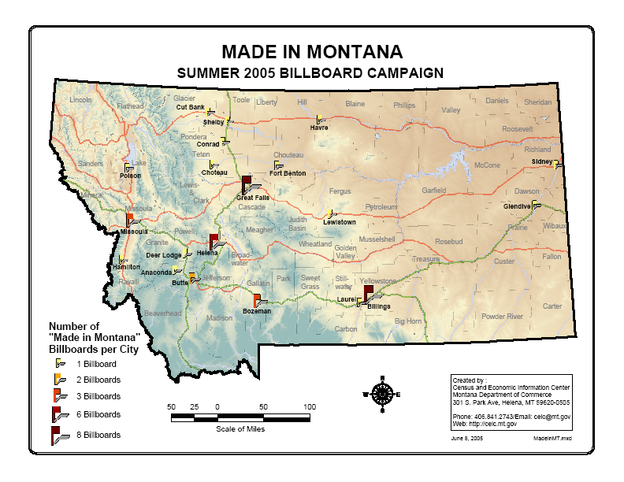

ECONOMIC DEVELOPMENT TAX INCENTIVE INITIATIVES

HB 584 - Big Sky on the Big Screen

Overview:
- HB 584 creates the Big Sky on the Big Screen Act and requires production companies to apply to the Department of Commerce for state certification of a production in order to qualify for the tax credits enumerated in the bill.
- The Film Office will be responsible for developing criteria for certification of production companies, as well as administrative rules for hearings, and revocation of certification.
- Under the bill, a production company can receive the following.
  - A 12% rebate based on hired Montana Labor. This incentive applies to the first $50,000 worth of wages paid per Montana Resident.
  - An 8% rebate based on qualified expenditures which consist of hotel and lodging expenditures, production equipment rental, fuel costs, expendables, lumber/construction materials, vehicle rentals, and food expenditures.

Status:
- The Governor has appointed a 26 member Film Commission to provide advice to the Department and act as Ambassadors for the State of Montana in promoting film and TV production in the State. Members of the Commission are;
- Jim Abel, Billings - Producer/ Writer, Out In The Cold Productions
- Dennis Aig, Bozeman - Professor of Media and Theatre Arts, MSU Bozeman, small business owner, The Hunter Neil Company
- Dean Bear Claw, Billings - Producer/Director/Writer
- Troy Bertelsen, Bozeman - Actor, Assistant Director
- William Campbell, Livingston - Documentary Producer, Homefire Productions
- Mona Charles, Kalispell - Editor, World Airline Entertainment Association Industry News, former actress and production coordinator and producer
- Betty Ann Conard, Manhattan - Free-lance film industry professional
- Christopher Cronyn, Missoula - Freelance film producer
- Colin Davis, Livingston - Partner/General Manager, Chico Hot Springs Resort
- Robert Ebinger, Jr., Livingston - Director of Photography, Buffalo Jump Pictures
- Paul Edwards, Helena - Screenwriter, Producer, Director
- Mike Fantasia, Los Angeles/Libby - Location Manager
- Peter Fonda, Livingston - Actor/Adjunct Film Professor at MSU
- J.P. Gabriel, Bozeman - Lighting Designer/Producer, Filmlites Montana LLP
- David Goodwin, Bozeman - Producer/Composer
- Audrey Hall, Livingston - Photographer, Writer, Producer
- Cinda Holt, Stevensville - Business Development Specialist, Montana Arts Council and former managing director, Sundance Film Festival
- Diane Kamp, Big Timber - Film Agent
- Margot Kidder, Bozeman - Actress
- Bert Manzari, Whitefish - Film buyer; consultant to Sony Classics Pictures
- Patrick Markey, Bozeman - Film producer, CMI
- Tom Mickel, Bozeman - Film producer, CMI
- Ed Noonan, Helena - Film educator at Carroll College, art director, Executive Director Myrna Loy Center
- Rob Story, Emigrant - Location Manager, MondoMonk
- Allison Whitmer, Wolf Point - Film and television production
- Jake Whittenberg, Billings - News reporter, KTVQ-TV, Production assistant/music videos
- Tony Preite, Director of the Department of Commerce
- The Department (Montana Film Office) is preparing for the first Commission meeting, which will occur in July.

SB 133 – Montana Equity Capital Investment Act

Overview:
- SB 133 establishes the Montana Equity Capital Investment Act to provide investment incentives to nourish the creation of a private seed and venture capital industry to fund academic, technological, and innovative companies. SB 133 authorizes the issuance of up to $60 million in State of Montana tax credits to investors in the Montana Equity Fund. SB 133 requires the Board to charge an annual fee to the designated investor group for administration of the Act. Section 4 of the Bill creates the board, which consists of five voting members and administratively attaches the Board to the Department of Commerce.

Status:
- The Legislature did not appropriate the general fund necessary to implement the Act. At the present time, the Department is not undertaking any activity since there is no funding to hire staff, to pay for the Capital Investment Board to meet, or to expend any funds on other necessary expenses including rent, phone, travel, consulting etc.

